Dr. Debalina Sengupta
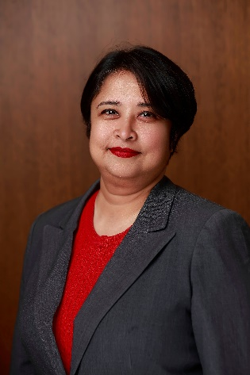
Dr. Debalina Sengupta’s research has focused on sustainability in the context of process systems engineering. She has worked on process design, integration, intensification, optimization, life cycle assessment and other related concepts for sustainable supply chain design of biofuels, natural gas, consumer products, waste valorization, and decision-making in sustainability using metrics and indicators. In recent times, she has expanded these concepts in application for energy transition, sustainable and integrated design of process systems, advanced manufacturing, and disaster resilient design. She has also been actively involved in the development of educational modules for sustainable manufacturing.
Dr. Sengupta is currently appointed as the Assistant Vice President - Energy Transition Institute at the University of Houston. Previously, she held the role of Coastal Resilience Program Director for Texas Sea Grant at Texas A&M University and had courtesy appointments as a fellow at the Institute of Science, Technology and Public Policy at the Bush School of Government and Social Service and as a Graduate Faculty at the Artie McFerrin Department of Chemical Engineering. Prior to that, she held the position of Associate Director of the TEES Gas and Fuels Research Center; Water, Energy and Food Nexus Coordinator at Texas A&M Energy Institute; and Lecturer at the Artie McFerrin Department of Chemical Engineering. Her roles included setup of the TEES Gas and Fuels Research Center American operations and developing collaborative research with international researchers from over 15 countries. Her current interests are related to resilience in the process industrial sector under disaster conditions, and energy transition.
She has authored two books, “Chemicals from biomass: integrating bioprocesses into chemical production complexes for sustainable development” by CRC Press (2012), and “Measuring Progress towards Sustainability” by Springer (2017). Apart from this, she has several peer reviewed journal publications, book chapters, and conference proceedings.
Dr. Sengupta is passionate about quantifying sustainability into action and implementation, and strives to work with diverse underrepresented people across the world. She is a critical thinker and likes to blog, read, and write in her spare time. Her interests also are in cooking, traveling, and photography. She enjoys spending time with family and friends. Her favorite places are New Orleans, Louisiana, USA, and Kolkata, West Bengal, India, her hometown.

