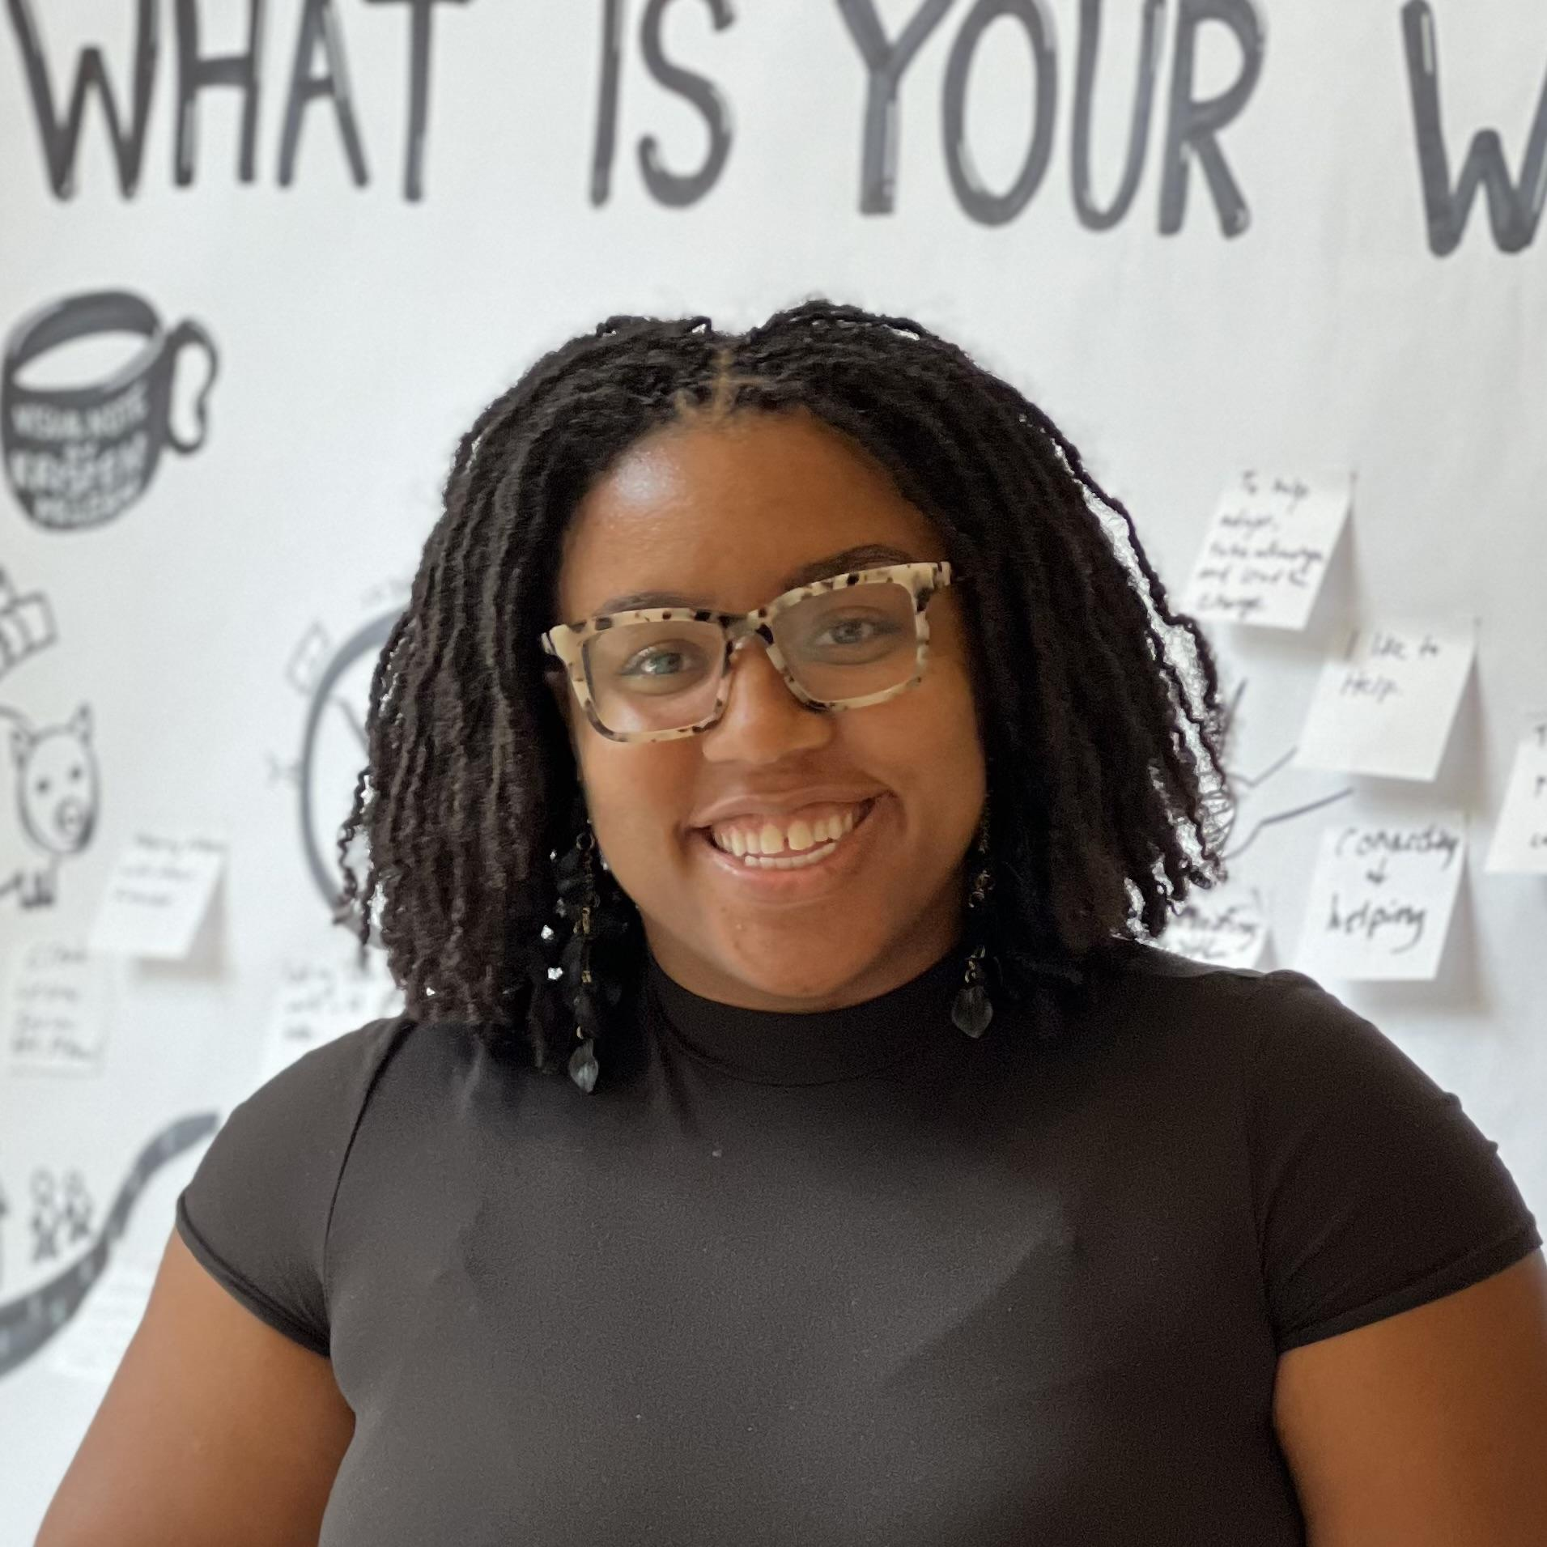

**Kristen McLean**

Kristen McLean is a visual notetaker. She sketches the ideas and key messages of presentations. By capturing the flow of presentations in real-time, Kristen ensures that every voice is heard and valued, fostering a collaborative atmosphere where participants can engage freely. Kristen brings her 15+ years of using doodles to break down complex ideas. The graphics created will be available for you to reflect on during and after the session. A digital copy will also be provided to you.

Kristen McLean’s favorite question is “How?”. Fascinated by how things are made, she chose to study Chemistry and Chemical Engineering at Oakwood University and The University of Alabama in Huntsville.

Born and raised in the Space City (Houston, Texas, USA), Kristen’s childhood ambition was to explore outer space. Kristen initially pursued a career path that took her to NASA and ExxonMobil before transitioning to a leadership role at Johnson & Johnson. A seasoned corporate girly, Kristen now uses those cross functional experiences to improve communication for organizations as a visual notetaker.

Her colleagues describe her as relentlessly optimistic, encouraging, energetic, and a creative communicator. When she's not illustrating ideas, she enjoys discussing everything from the wonders of space to her favorite travel destinations. Feel free to say hello and ask her about her adventures in motherhood, spaghettification, or the latest place she’s explored.